| Test 3 — Version D | |
| --- | --- |
| Course Information: Phys 2A | Instructor Name: John R. Walkup |

### Equations Provided

***d*** = ***v***o*t* + (1/2)***a****t*2 ***v*** = ***v***o + ***a****t*  ***F***net = *m****a*** ***F***g = *m***g** *F*fr ≤ s*N*  *F*fr = k*N*  *= Fr* sin *WC = –*PE *WNC =* E *Wnet =* 😐 *W* = *Fd*cos     😐  *mv*2 PE = *mgh* *s* = *r* *v* = r *a* = *r* net = *I*   = o + *t*  = o*t* + (1/2)*t*2

#### Multiple choice questions (4 points each)

1. A block slides up a rough inclined plane. The normal force acting on the block…
2. is a non-conservative force that does positive work on the block.
3. is a non-conservative force, but does not do any work on the block
4. is a non-conservative force that does negative work on the block.
5. is a conservative force that does positive work on the block.
6. is a conservative force, but does not do any work on the block
7. A mechanic pushes a 2,700-kg car from rest to a speed of *v*, doing 4,860 J of work in the process. During this time, the car moves 23.0 m. Neglecting friction between car and road, find *v*.
8. 1.1 m/s
9. 9.3 m/s
10. 5.4 m/s
11. 3.4 m/s
12. 1.9 m/s
13. The (mechanical) energy of a system is conserved…
14. During an elastic collision
15. When no nonconservative force does work on the system
16. When no net external force acts on the system.
17. Both (a) and (b)
18. 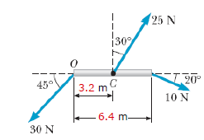Both (a) and (c)
19. The figure shows a horizontal rod, of length 6.4 m, with forces acting on it. A 30 N force acts at its left end, point O, in a direction down and to the left, 45° below horizontal. A 25 N force acts at its center, point C, in a direction up and to the right, 30° to the right of vertical. A 20 N force acts at the right end, in a direction down and to the right, 20° below horizontal. What is the net torque (in N · m) on the rod about an axis through C perpendicular to the page?
20. 56.9
21. 47.1
22. 35.7
23. 41.5
24. 0
25. A large grinding wheel in the shape of a solid cylinder of radius 0.330 m is free to rotate on a frictionless, vertical axle. A constant tangential force of 300 N applied to its edge causes the wheel to have an angular acceleration of 0.886 rad/s. If the wheel starts from rest, what is its angular velocity after 5.90 s have elapsed, assuming the force is acting during that time?
26. 4.44 rad/s
27. 5.23 rad/s
28. 6.19 rad/s
29. 2.39 rad/s
30. 8.30 rad/s
31. A dentist's drill starts from rest. After 4.90 s of constant angular acceleration it turns at a rate of 29,000 rev/min. How many rotations does the drill undergo during this time period? (There are 2 revolutions in one rotation.)
32. 1,185
33. 2,369
34. 46,723
35. 23,362
36. 4,738
37. A 44.0-cm diameter disk rotates with a constant angular acceleration of 2.60 rad/s. It starts from rest. At *t* = 2.44 s, find the angular speed of the wheel.
38. 1.34 rad/s
39. 2.44 rad/s
40. 4.84 rad/s
41. 6.34 rad/s
42. 8.22 rad/s
43. A rifle with a weight of 20 N fires a 5.5-g bullet with a speed of 250 m/s. Find the recoil speed of the rifle.
44. 0.34 m/s
45. 1.34 m/s
46. 0.67 m/s
47. 0.07 m/s
48. 0 (there is no recoil)
49. A certain light truck can go around a flat curve having a radius of 150 m with a maximum speed of 30.5 m/s. With what maximum speed can it go around a curve having a radius of 68.5 m?
50. 16.0 m/s
51. 20.6 m/s
52. 24.2 m/s
53. 32.8 m/s
54. 28.4 m/s
55. 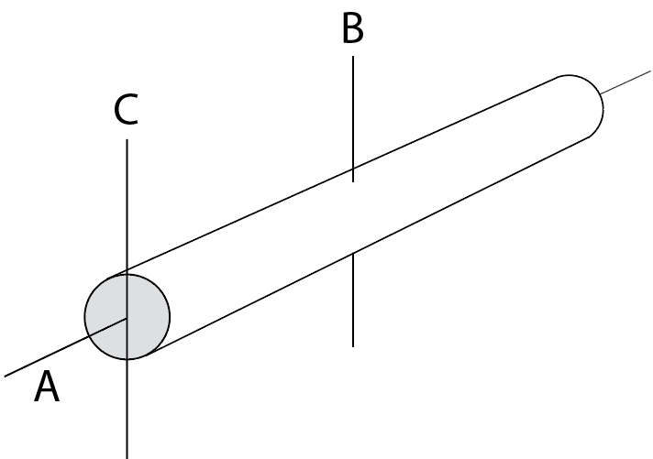Consider the moment of inertia I of a long steel pipe, as shown. Axes of rotation A, B and C are shown, so IA is the moment of inertia about axis A, and so on. Which of the following is correct?
56. IA = IB and IB = IC
57. IA > IB and IB > IC
58. IA < IB and IB < IC
59. IA > IB and IB < IC
60. IA < IB and IB > IC

#### Computations (10 points each)

1. 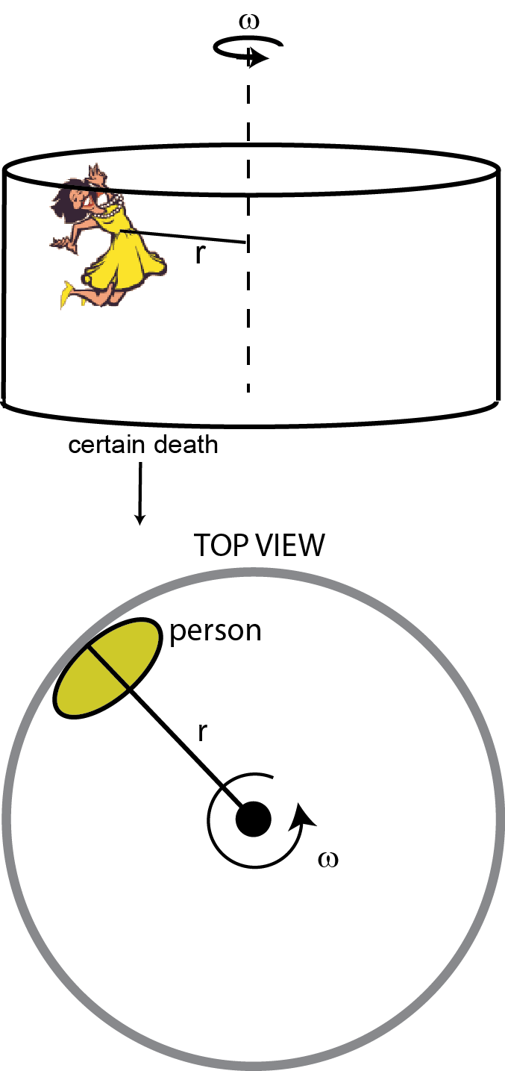The Gravitron is an amusement ride that is a large steel cylinder spinning at a constant rate about its vertical axis. People stand up against the inside wall of the cylinder while it spins. Friction between their backs and the wall keep them from sliding down.

In this particular ride, the radius of the Gravitron is 5 m. Engineers have estimated that the fastest they can spin such a large Gravitron is 0.5 radians per second. They are concerned that some people might wear clothing that is so smooth that they will fall out of the Gravitron. (Use *g* = 10 m/s2.)

1. Calculate the minimum coefficient of static friction that the people will need to keep from sliding down the Gravitron’s wall. (Use *g* = 10 m/s2.)
2. I never stated the mass of the person in this problem. Why was this information unnecessary?
3. During ten seconds of operation, how far (in meters) will the person travel through space?
4. In the figure, a man pushes on the outside edge of a merry-go-round with a constant 80 newton force. The merry-go-round is originally at rest. He manages to force the merry-go-round to spin through two complete revolutions in 30 seconds. (1 revolution = 2 radians)
5. 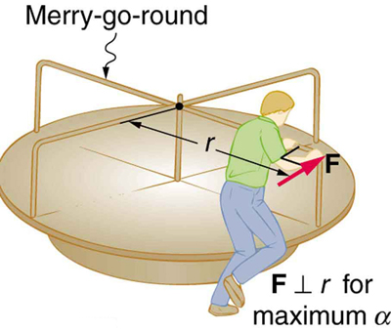Assume the radius of the merry-go-round is   
   3 meters and that the man’s force is the only force applying a torque to the merry-go round. What is the moment of inertia of the merry-go-round?
6. How fast is a point on the outside edge of the merry-go-round traveling through space at the 30-second mark?
7. A bullet with mass *m* = 0.1 kg grams traveling at 500 m/s hits a ballistic pendulum with a block of mass *M* and lodges inside it. The block (and bullet) swings up to a height 0.20 meters above its original elevation. In this problem, you will determine the mass *M* of the block.
8. Draw a picture of the ballistic pendulum, labeling the physical properties involved in the problem. (Be neat!)
9. While the bullet is embedding into the block, is energy conserved? Why or why not?
10. While the bullet is embedding into the block, is momentum conserved? Why or why not?
11. When the pendulum swings up to its maximum angle, is energy conserved? Why or why not?
12. When the pendulum swings up to its maximum angle, is momentum conserved? Why or why not?
13. Find the mass of the block.